EX NO: 3 – Identify Use Cases and Develop the Use Case Model
Aim:
To identify actors (Admin, Passenger, Airline Staff) and create a Use Case diagram representing system interactions for the Airline Reservation System.

Use Case Diagram Description
The Airline Reservation System (ARS) includes three main actors:
✔ Admin – Manages flight schedules, system data, and generates reports.
✔ Airline Staff – Assists passengers, manages bookings, and checks booking status.
✔ Passenger – Searches flights, books tickets, cancels reservations, and makes payments.

Use Cases
Admin:
✔ Manage Flights (Add, Update, Remove Flight Details)
✔ Manage Fare and Schedule
✔ Generate Reports (Booking Reports, Revenue Reports)

Airline Staff:
✔ View Booking Details
✔ Assist Passenger Booking
✔ Check Seat Availability

Passenger:
✔ Register Account
✔ Login to System
✔ Search Flights
✔ Book Tickets
✔ Cancel Tickets
✔ Make Payment
USE CASE DIAGRAM
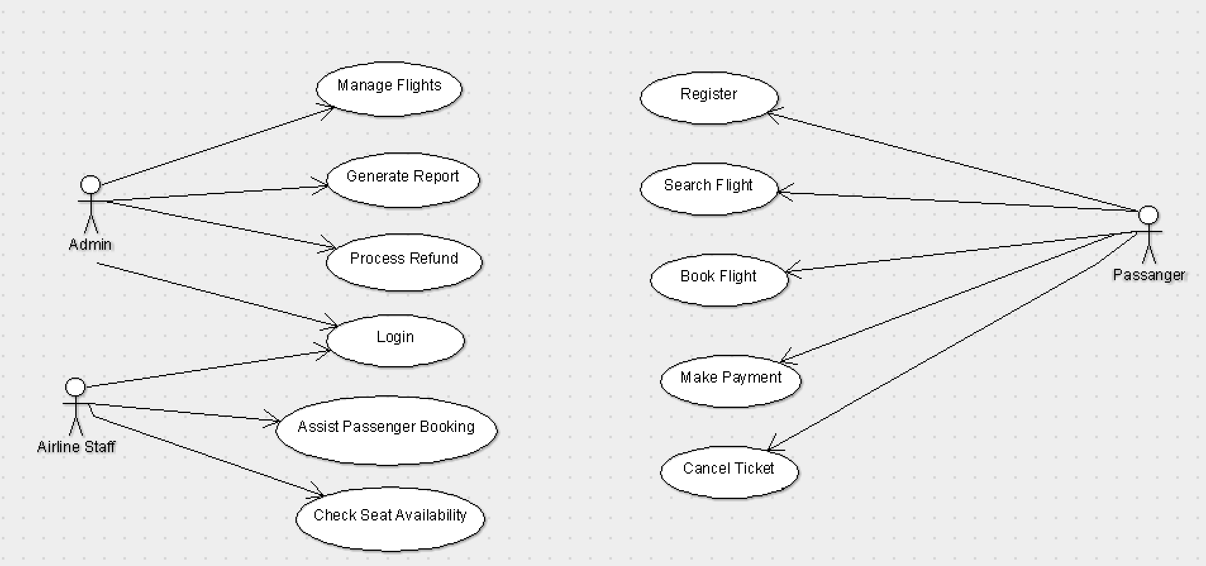
Result:
Thus, the use cases were identified for the Airline Reservation System and the Use Case Model was developed using ArgoUML.
EXP NO : 4
IDENTIFY THE CONCEPTUAL CLASSES & DEVELOP A DOMAIN MODEL AND ALSO DESIGN CLASS DIAGRAM FROM THAT
Project Title: Airline Reservation System (ARS)

Domain Model Description
The Domain Model represents the real-world entities and their relationships in the Airline Reservation System.
The System (ARS) manages overall operations such as login, booking, cancellation, and report generation.
User is a general class representing all users of the system.
Admin manages flights, schedules, and generates reports.
Passenger searches flights, books tickets, and cancels reservations.
Flight contains flight information such as source, destination, schedule, and seat availability.
Booking stores booking details including seat number, booking status, and date.
Payment handles payment transactions and refund processing.
These classes interact with each other to provide a complete airline reservation system.

CLASS DIAGRAM:
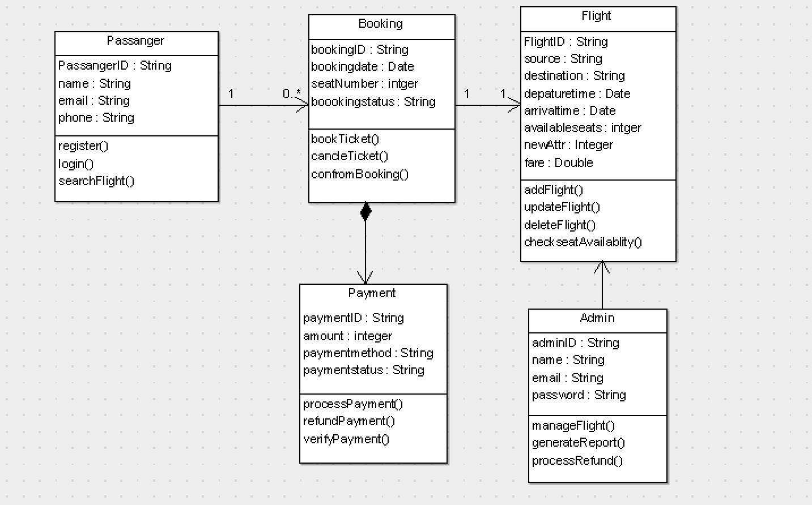
RESULT:
Thus, real-world entities such as User, Admin, Passenger, Flight, Booking, and Payment were successfully identified, the Domain Model was developed, and the Class Diagram was created, showcasing relationships, attributes, and methods in the Airline Reservation System (ARS).
EX NO: 5 USING THE IDENTIFIED SCENARIOS FIND INTERACTIONS BETWEEN OBJECTS AND REPRESENT THEM USING UML SEQUENCE AND COLLABORATION DIAGRAM
Project Title: Airline Reservation System (ARS)

Sequence Diagram – Description
The Sequence Diagram shows the order of interactions between objects over time.
Example Interaction (Passenger booking a flight):
- Passenger sends login request to the system.
- System verifies user credentials.
- Passenger searches for available flights.
- System retrieves flight details from Flight class.
- Passenger selects a flight and books ticket.
- System checks seat availability.
- System processes payment through Payment class.
- Booking is confirmed and ticket is generated.

SEQUENCE DIAGRAM:
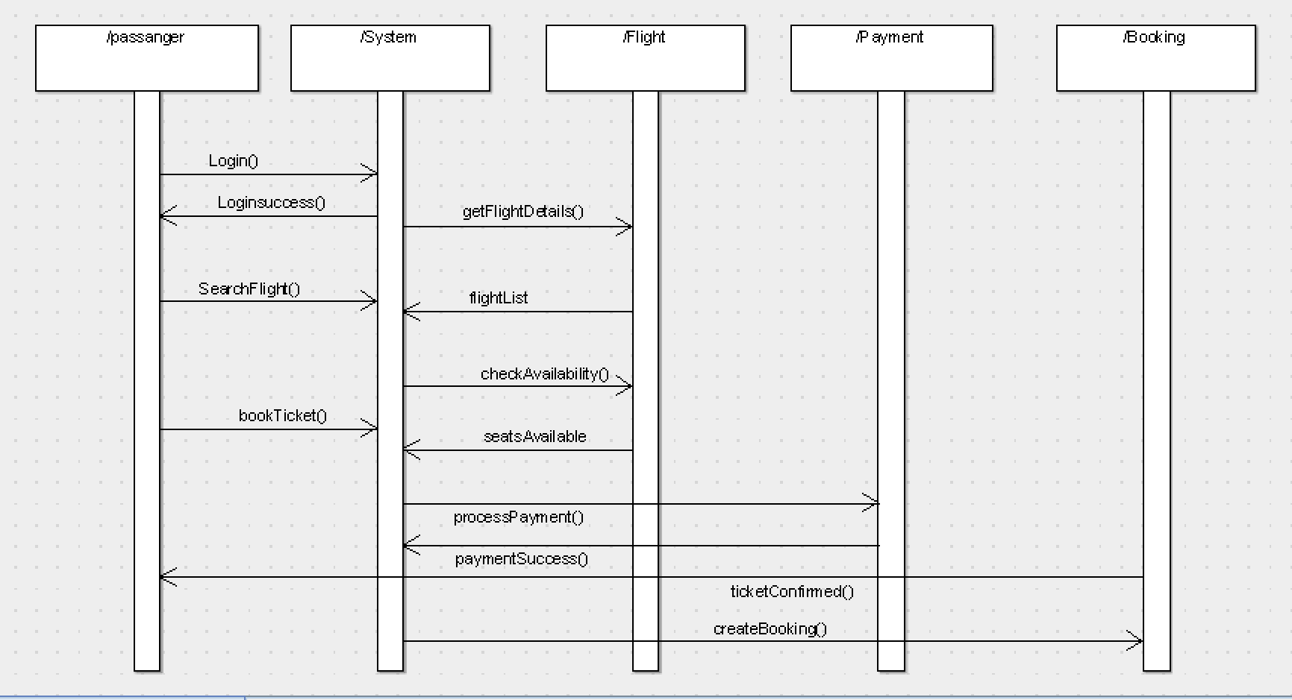
Collaboration Diagram – Description
The Collaboration Diagram shows how objects interact and their relationships.
- Admin manages flight schedules and system data.
- Passenger searches flights, books tickets, and cancels reservations.
- Flight provides flight details and seat availability.
- Booking connects Passenger and Flight.
- Payment handles payment and refund processing.

COLLABORATION DIAGRAM:
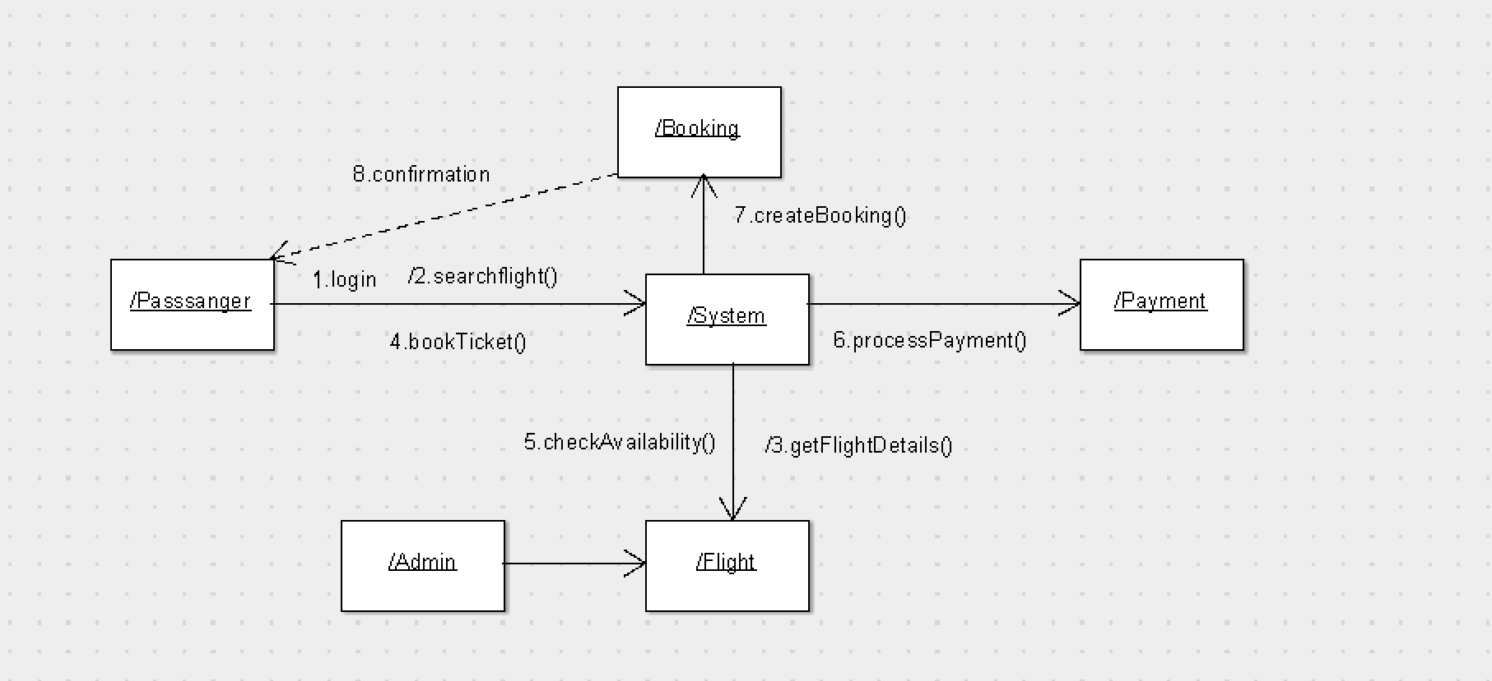
RESULT:
Thus, the identified scenarios were successfully used to create Sequence Diagrams for key interactions (login, flight search, booking, and payment) and Collaboration Diagrams for object interactions in the Airline Reservation System.
EXP NO: 6
DRAW RELEVANT STATE CHART AND ACTIVITY DIAGRAMS FOR SAME SYSTEM
Project Title: Airline Reservation System (ARS)

State Diagram – Description
The State Diagram represents the different states of a Passenger in the Airline Reservation System during system usage.
Initially, the system is in the Logged Out state.
When the user enters valid credentials, it moves to the Logged In state.
After login, the user enters the Flight Search state to search for available flights.
Then the system transitions to Flight Selection where the user selects a desired flight.
Next, the system moves to the Booking State, where ticket booking is initiated.
After booking, the system enters the Payment Processing state to complete the transaction.
If payment is successful, the system moves to the Ticket Confirmed state.
The user may also enter the Cancellation State to cancel the ticket if required.
Finally, the system reaches the Logout/End state after completing all activities.

STATE DIAGRAM:
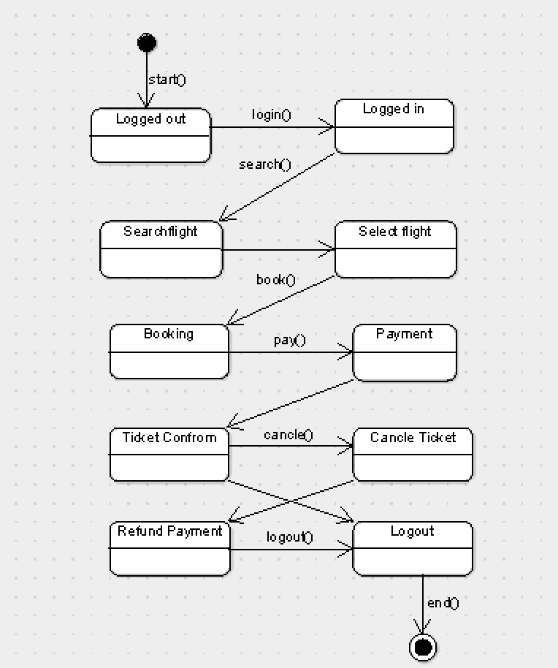
Activity Diagram – Description
The Activity Diagram illustrates the workflow of activities in the Airline Reservation System.
The process starts with the Login activity.
The system verifies user credentials using a decision node (valid/invalid).
If valid, the user proceeds to Search Flights.
Then the user selects a flight using Select Flight activity.
Next, the user performs Book Ticket.
The system checks Seat Availability.
Then the system performs Payment Processing.
If payment is successful, the system confirms booking (Ticket Confirmation).
Finally, the process ends after completion or logout.

ACTIVITY DIAGRAM:
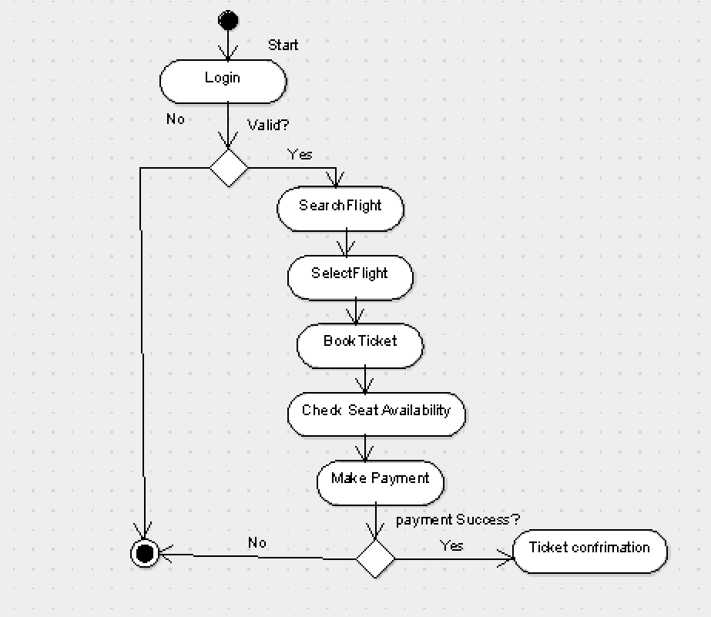
Deployment Description
The Deployment Diagram shows the physical structure of the Airline Reservation System.
It includes Client Device, Web Server, Application Server, and Database Server.
- The Client Device (Passenger/Admin) accesses the system through a web or mobile application.
- The Web Server handles user requests and provides the interface.
- The Application Server processes booking, payment, and business logic.
- The Database Server stores flight details, passenger data, and booking records.
All components are connected through a network to ensure smooth communication.

DEPLOYMENT DIAGRAM:
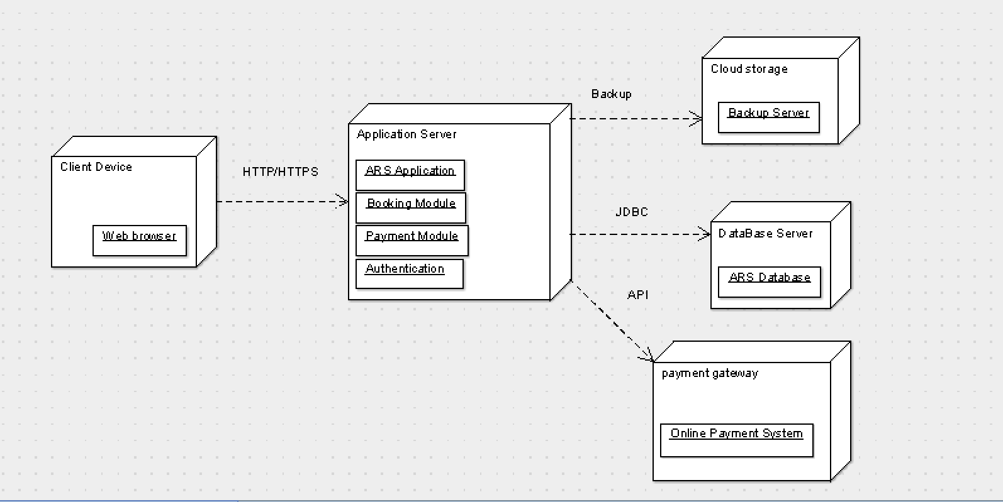
RESULT:
Thus, the state changes of a passenger and key workflows in the Airline Reservation System (ARS) were successfully modeled using State Chart and Activity Diagrams, along with the Deployment Diagram representing system architecture.

